git --version

git init

git config (--global) user.name “Dejan Zmijanac”
git config (--global) user.email “zmijanacd@gmail.com”
git config core.autocrlf true (for win)
git config core.autocrlf input (for linux)
git config (--global) core.editor "code –wait"
git config -e

git add <filename>
git add -A (all changed files in current dir)
git add a . (all changed files in repo dir)

git status
git status --short

git commit -m <message>
git commit (opens a textbox for longer commit messages, quits with → Q)

git log → shows log history of the current branch
git log origin/master → shows log history of origin/master branch

git <command> –help → See all the available options for the specific command
git help –all → See all possible commands

git branch <new branch name> → creates new branch
git branch → lists all branches
git branch -d <branch name> → deletes a branch
git branch -a → lists all the branches

git checkout <branch name> → switches to another branch

git merge <branch name> → merge the current branch with the <branch name>

git diff <branch name> → shows the difference from current branch with the <branch name>

git remote add origin URL → adding a remote repository

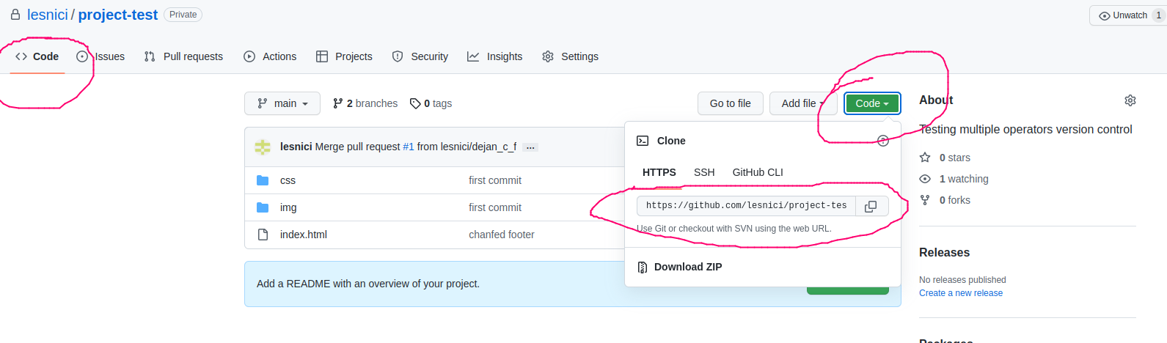
git push --set-upstream origin master (or main) →pushes our master branch to the origin url, and set it as the default remote branch
if not than
git push origin master (or main) –force
git push origin <branch name> →pushes <branch name> branch to the origin url, and set it as the default remote branch

Note: Since this is the first time you are connecting to GitHub, you will get some kind of notification you to authenticate this connection.
Username: login email address
password: token
How to get a token: Profile icon → Settings → Developer settings (on the left menu vertical bar) →
Personal access tokens

git pull origin → update your local repository from origin

Create a new branch in github:
On GitHub, access your repository and click the "master" branch button.
There you can create a new Branch. Type in a descriptive name, and click Create branch.

Creating a github pages (deploying a website):
Repository tab → Settings → Pages → Github Pages Tab select branch (this brunch will be published)
Note: The whole project must be public not private in order for github pages to work.

